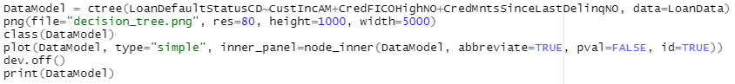

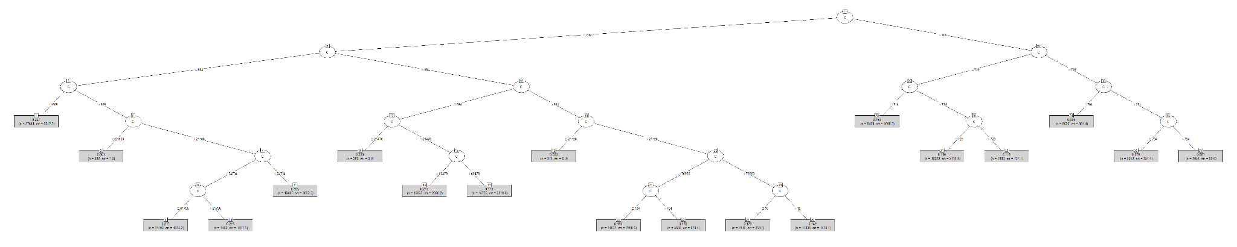

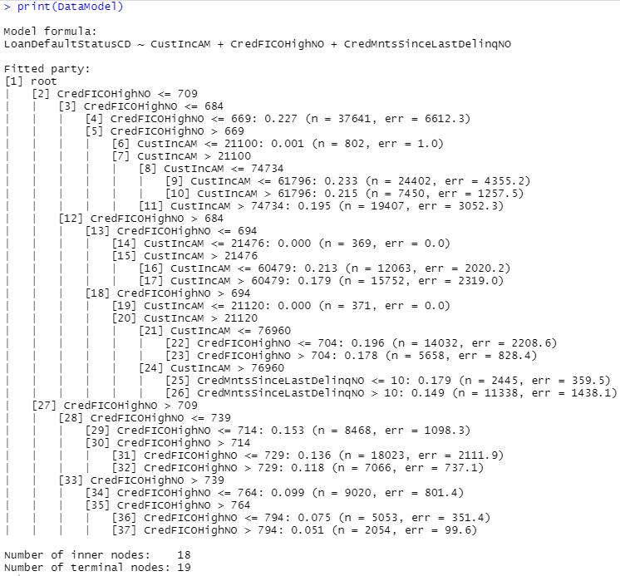

This decision tree, despite having limited variables, was still too large for what we were looking for in this assignment, therefore the depth of the decision tree must be limited.



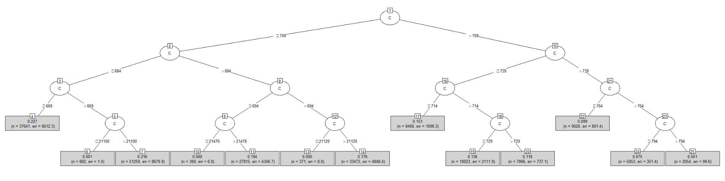

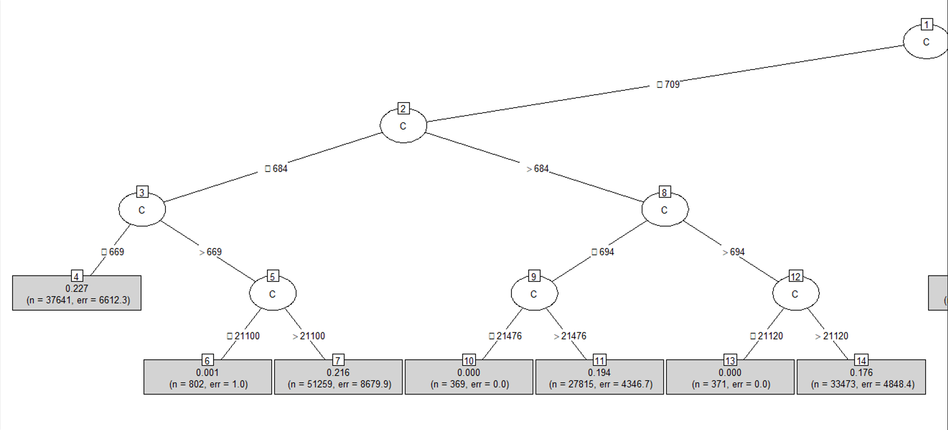

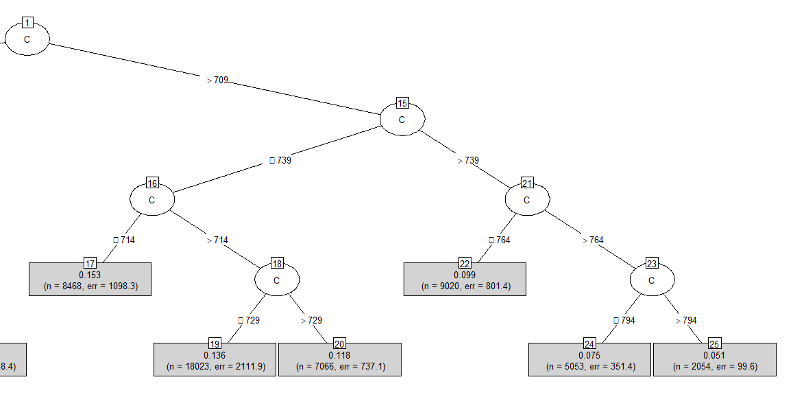

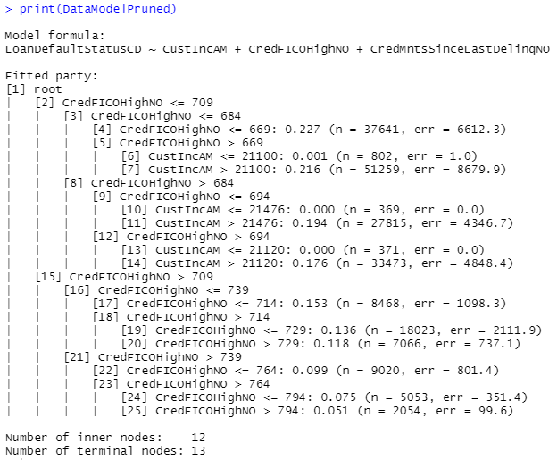

This decision tree was much simpler, and therefore easier to read. When pruning the decision tree, the best variable to use for determining whether the customer would default on their loan or not was the CredFICOHighNO variable. CustIncAM was also a significant variable in determining whether or not the customer would default when on a max depth of 4 for the decision tree. From the full decision tree prior to the pruned one, it appears that FICO score takes priority in the first stages of the decision tree. Therefore we recommend using FICO score to determine whether or not you should loan to customers, the pricing of the loans, and the interest rates. Along with FICO score, customer income can be helpful in deciding lending standards.The error rates of the customer defaulting for both of the decision trees is rather small for many parts of the tree.

For example, if the profit target was 5%, and the cost of capital was 3%...

| Group | 4 | 6 | 7 | 22 | 24 | 25 |
| --- | --- | --- | --- | --- | --- | --- |
| Income | N/A | x<$21100 | Over $21100 | N/A | N/A | N/A |
| FICO Score | x<669 | 669<x<684 | 669<x<684 | 739<x<764 | 764<x<794 | Over 794 |
| Profit target | 5% | 5% | 5% | 5% | 5% | 5% |
| Cost of capital | 3% | 3% | 3% | 3% | 3% | 3% |
| Default rate | 22.7% | 0.1% | 21.6% | 9.9% | 7.5% | 5.1% |
| Total Interest Rate | 30.7% | 8.1% | 29.6% | 17.9% | 15.5% | 13.1% |